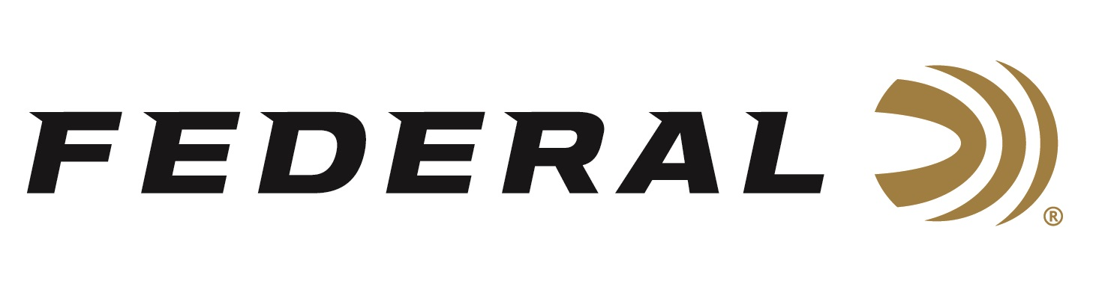
FOR IMMEDIATE RELEASE

Federal Ammunition Announces New Personal Defense HST
357 Magnum and 327 Federal Magnum

ANOKA, Minnesota – June 20, 2023 – Federal Ammunition announces new line options to the HST product family with the addition of Personal Defense HST 357 Magnum and 327 Federal Magnum. Continuing to build off an already extensive line of personal defense ammunition options, the addition of these magnum loads gives users a reliable and effective personal defense option for revolvers: Personal Defense HST | Federal Premium.

“When it comes to choosing a caliber for personal defense, the 357 Magnum and 327 Federal Magnum continues to be popular choices,” said Federal Ammunition Handgun Product Director, Nick Sachse. “A big reason for the continued popularity of these calibers is the preference to carry a revolver for everyday carry. We are excited to add these new loads to the already proven line of HST Personal Defense handgun ammunition.”

Reliability is key especially when it comes to choosing self-defense ammo. To remove any doubts of performance, the HST 357 Magnum and 327 Federal Magnum boast a nickel-plated case for long-term corrosion resistance. The high-performance primer and primer seal ensures consistent ignition when it is needed most.

“Users that want to carry a magnum caliber for personal defense, want to utilize the full benefit of them. The specially engineered 104-grain 327 Federal Magnum and 154-grain 357 Magnum HST Jacketed Hollow Points were designed to take full advantage of magnum cartridges with consistent terminal performance,” continued Sachse. “From a terminal performance standpoint, these magnum cartridges provide energy that allows for both excellent penetration and expansion. And like all HST bullets, this performance can be relied on through heavy clothing.”

The HST 357 Magnum and 327 Federal Magnum join an already proven line of Personal Defense HST products that include 30 Super Carry, 9mm Luger, 9mm Luger +P, 357 SIG, 40 S&W, 10mm Auto, 45 Auto, and 45 Auto +P.

Part No. / Description / MSRP
P327HST1S / 327 Federal Magnum HST JHP, 104-grain, 20-count / $39.99
P357HST1S / 357 Magnum HST JHP, 154-grain, 20-count / $44.99

For more information on all products from Federal Ammunition or to shop online, visit www.federalpremium.com.

Press Release Contact: JJ Reich
Senior Manager – Press Relations
E-mail: VistaPressroom@VistaOutdoor.com

About Federal Ammunition
Federal, headquartered in Anoka, MN, is a brand of Vista Outdoor Inc., an outdoor sports and recreation company. From humble beginnings nestled among the lakes and woods of Minnesota, Federal Ammunition has evolved into one of the world's largest producers of sporting ammunition. Beginning in 1922, founding president, Charles L. Horn, paved the way for our success. Today, Federal carries on Horn's vision for quality products and service with the next generation of outdoorsmen and women. We maintain our position as experts in the science of ammunition production. Every day we manufacture products to enhance our customers' shooting experience while partnering with the conservation organizations that protect and support our outdoor heritage. We offer thousands of options in our Federal Premium and Federal® lines-it's what makes us the most complete ammunition company in the business and provides our customers with a choice no matter their pursuit.

